# **Exercise 1: Logging Error Messages and Warning Levels**

Write a Java application that demonstrates logging error and warning messages using SLF4J with Logback as the backend.

### **Add SLF4J and Logback Dependencies**

In pom.xml:

<dependency>  
 <groupId>org.slf4j</groupId>  
 <artifactId>slf4j-api</artifactId>  
 <version>1.7.30</version>  
</dependency>  
<dependency>  
 <groupId>ch.qos.logback</groupId>  
 <artifactId>logback-classic</artifactId>  
 <version>1.2.3</version>  
</dependency>

<build>  
 <plugins>  
 <plugin>  
 <groupId>org.codehaus.mojo</groupId>  
 <artifactId>exec-maven-plugin</artifactId>  
 <version>3.1.0</version>  
 <configuration>  
 <mainClass>com.example.LoggingExample</mainClass>  
 </configuration>  
 </plugin>  
 </plugins>  
</build>

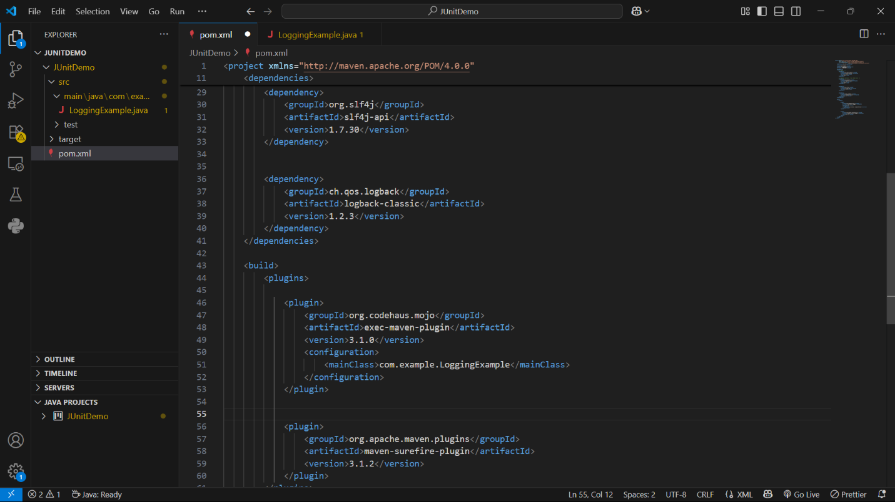

## **LoggingExample.java**

package com.example;  
  
import org.slf4j.Logger;  
import org.slf4j.LoggerFactory;  
  
public class LoggingExample {  
 private static final Logger logger = LoggerFactory.getLogger(LoggingExample.class);  
  
 public static void main(String[] args) {  
 logger.error("This is an error message");  
 logger.warn("This is a warning message");  
 }  
}

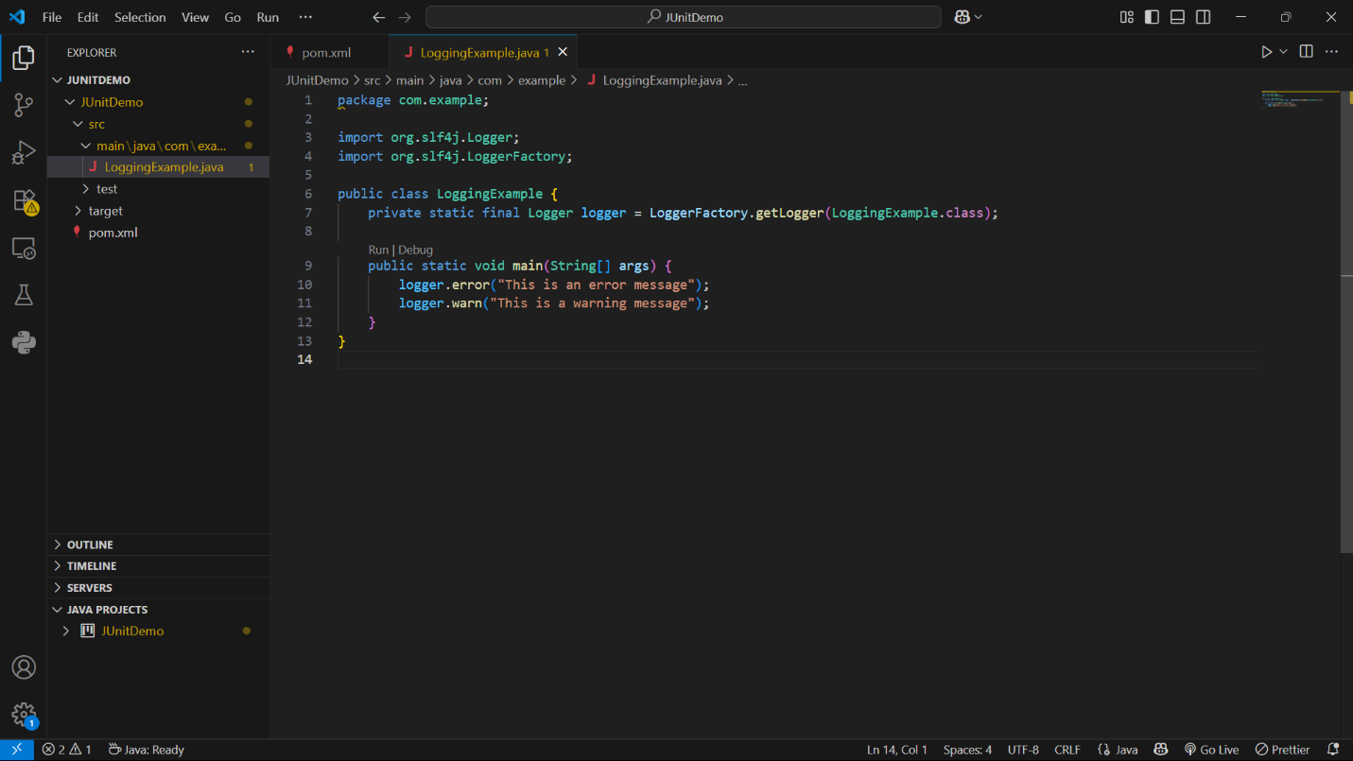

## **How to Run**

In your VS Code terminal:

mvn compile  
mvn exec:java

This will compile the project and run the main() method.

## **Sample Output**

12:00:00.123 [main] ERROR com.example.LoggingExample - This is an error message  
12:00:00.124 [main] WARN com.example.LoggingExample - This is a warning message

Logback shows the timestamp, thread, level, class, and message.

